“Spring Core and Maven”
Exercise 1: Configuring a Basic Spring Application
Scenario:
Your company is developing a web application for managing a library. You need to use the Spring Framework to handle the backend operations.
1.BookRepository.java
package com.library.repository;
public class BookRepository {
public void printBooks() {
System.out.println("📚 BookRepository: List of books");
}
}
2.BookService.java
package com.library.service;
import com.library.repository.BookRepository;
public class BookService {
private BookRepository bookRepository;
// Setter for DI
public void setBookRepository(BookRepository bookRepository) {
this.bookRepository = bookRepository;
}
public void showBooks() {
System.out.println("📖 BookService: Showing books using repository...");
bookRepository.printBooks();
}
}
3.MainApp.java
package com.library;
import com.library.service.BookService;
import org.springframework.context.ApplicationContext;
import org.springframework.context.support.ClassPathXmlApplicationContext;
public class MainApp {
public static void main(String[] args) {
ApplicationContext context = new ClassPathXmlApplicationContext("applicationContext.xml");
BookService service = context.getBean("bookService", BookService.class);
service.showBooks();
}
}
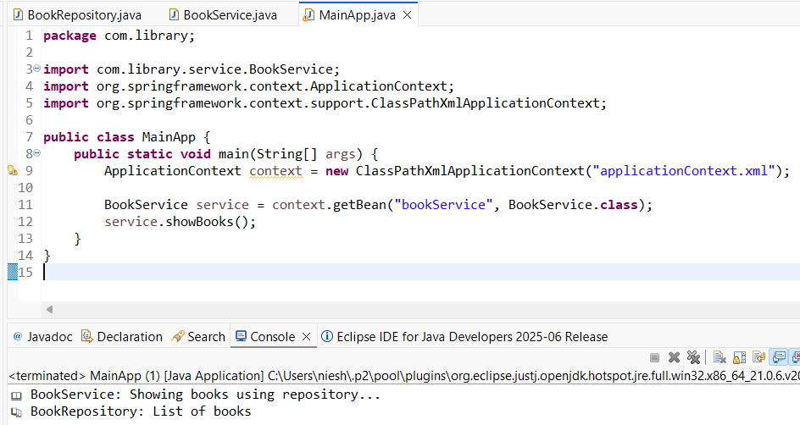
---------------------------------------------------------------------------------------------------------------------------
Exercise 2: Implementing Dependency Injection
Scenario:
In the library management application, you need to manage the dependencies between the BookService and BookRepository classes using Spring's IoC and DI.
1.BookRepository.java
package com.library.repository;
public class BookRepository {
public void displayBooks() {
System.out.println("Displaying books from the repository...");
}
}
2.BookService.java
package com.library.service;
import com.library.repository.BookRepository;
public class BookService {
private BookRepository bookRepository;

// Setter for DI
public void setBookRepository(BookRepository bookRepository) {
this.bookRepository = bookRepository;
System.out.println("BookRepository injected via setter");
}
public void listBooks() {
bookRepository.displayBooks();
}
}
3.MainApp.java
package com.library;
import com.library.service.BookService;
import org.springframework.context.ApplicationContext;
import org.springframework.context.support.ClassPathXmlApplicationContext;
public class MainApp {
public static void main(String[] args) {
// Load the Spring IoC container
ApplicationContext context = new ClassPathXmlApplicationContext("applicationContext.xml");
// Retrieve the bean and invoke method
BookService service = context.getBean("bookService", BookService.class);
service.listBooks();
}
}
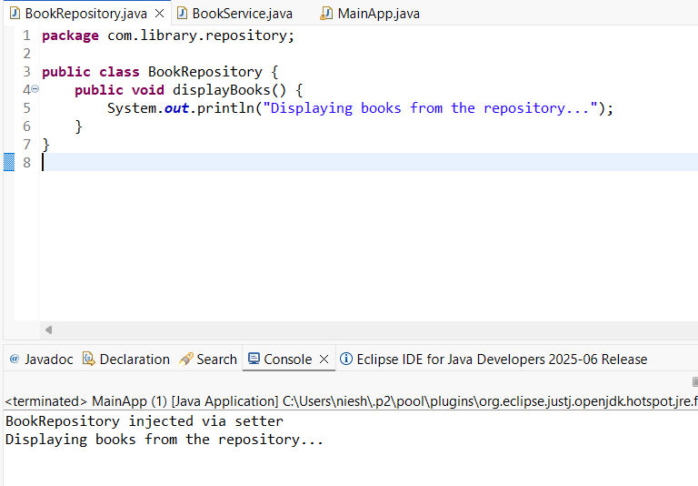
---------------------------------------------------------------------------------------------------------------------------
Exercise 3: Implementing Logging with Spring AOP
Scenario:
The library management application requires logging capabilities to track method execution times.
1.MainApp.java
package com.library;
import org.springframework.context.ApplicationContext;
import org.springframework.context.support.ClassPathXmlApplicationContext;
import com.library.service.BookService;
public class MainApp {
public static void main(String[] args) {
ApplicationContext context = new ClassPathXmlApplicationContext("applicationContext.xml");
// Spring automatically injects component-scanned beans
BookService bookService = context.getBean(BookService.class);
bookService.addBook();
bookService.deleteBook();
}
}
2.BookService.java
package com.library.service;
import org.springframework.stereotype.Component;
@Component
public class BookService {
public void addBook() {
System.out.println("Book added to the system.");
}
public void deleteBook() {
System.out.println("Book deleted from the system.");
}
}
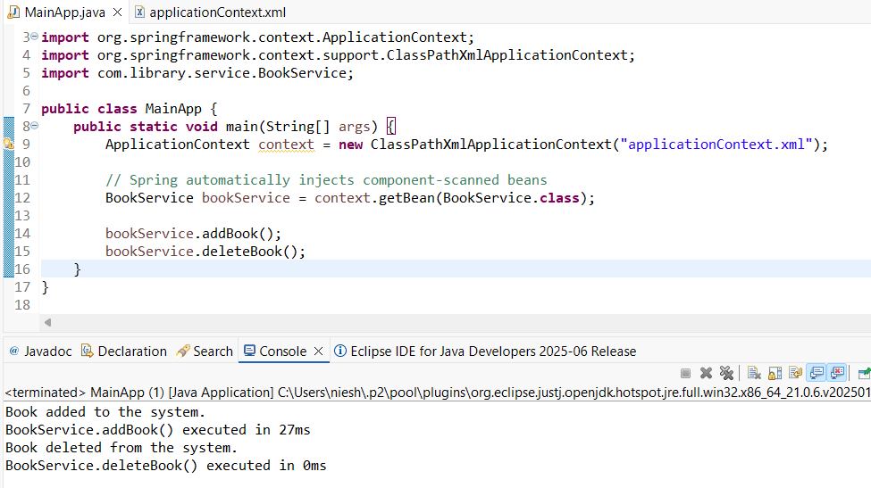
---------------------------------------------------------------------------------------------------------------------------
Exercise 4: Creating and Configuring a Maven Project
Scenario:
You need to set up a new Maven project for the library management application and add Spring dependencies.

1.MainApp.java
package com.library;
import org.springframework.context.ApplicationContext;
import org.springframework.context.support.ClassPathXmlApplicationContext;
public class MainApp {
public static void main(String[] args) {
System.out.println("Library Management Application Started");
ApplicationContext context = new ClassPathXmlApplicationContext("applicationContext.xml");
} }

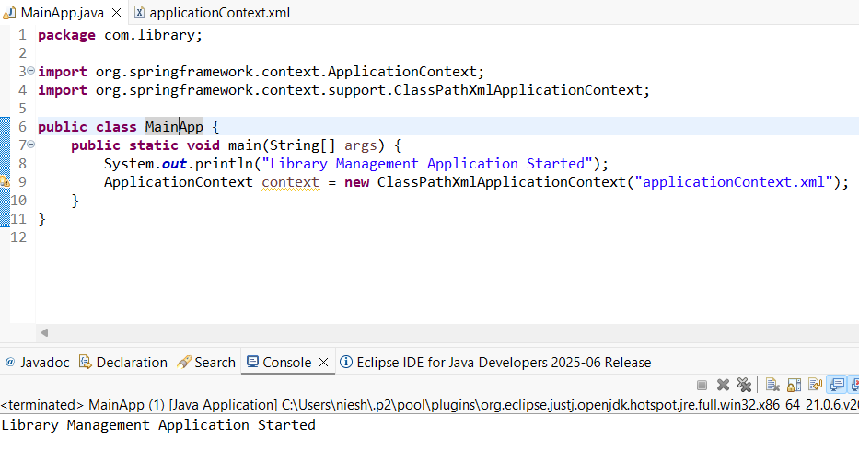
---------------------------------------------------------------------------------------------------------------------------
Exercise 5: Configuring the Spring IoC Container
Scenario:
The library management application requires a central configuration for beans and dependencies.
1.BookService.java
package com.library.service;
import com.library.repository.BookRepository;
public class BookService {
private BookRepository bookRepository;
// Setter for dependency injection
public void setBookRepository(BookRepository bookRepository) {
this.bookRepository = bookRepository;
}
public void listBooks() {
bookRepository.displayBooks();
}
}
2.BookRepository.java
package com.library.repository;
public class BookRepository {
public void displayBooks() {
System.out.println("Displaying list of books...");
}
}
3.MainApp.java
package com.library;
import com.library.service.BookService;
import org.springframework.context.ApplicationContext;
import org.springframework.context.support.ClassPathXmlApplicationContext;
public class MainApp {
public static void main(String[] args) {
// Load Spring configuration file
ApplicationContext context = new ClassPathXmlApplicationContext("applicationContext.xml");
// Get BookService bean and call method
BookService service = context.getBean("bookService", BookService.class);
service.listBooks();
}
}
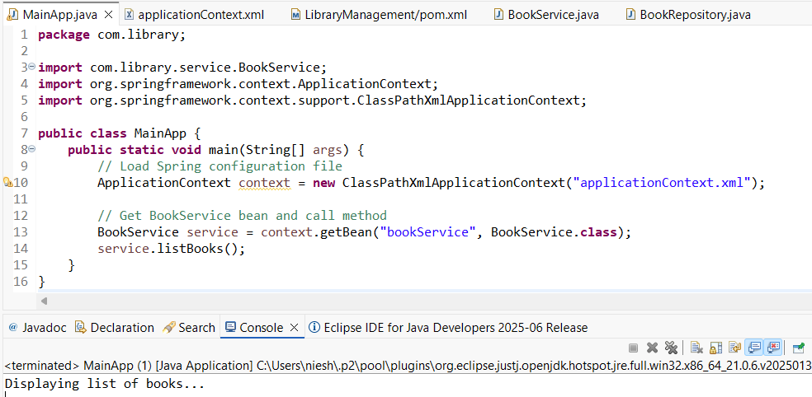
---------------------------------------------------------------------------------------------------------------------------
Exercise 6: Configuring Beans with Annotations
Scenario:
You need to simplify the configuration of beans in the library management application using annotations.

1.MainApp.java
package com.library;
import com.library.service.BookService;
import org.springframework.context.ApplicationContext;
import org.springframework.context.support.ClassPathXmlApplicationContext;
public class MainApp {
public static void main(String[] args) {
ApplicationContext context = new
ClassPathXmlApplicationContext("applicationContext.xml");
BookService service = context.getBean(BookService.class);
service.listBooks();
}
}

2.BookService.java
package com.library;
import com.library.service.BookService;
import org.springframework.context.ApplicationContext;
import org.springframework.context.support.ClassPathXmlApplicationContext;
public class MainApp {
public static void main(String[] args) {
ApplicationContext context = new
ClassPathXmlApplicationContext("applicationContext.xml");
BookService service = context.getBean(BookService.class);
service.listBooks();
}
}

3.BookRepository.java
package com.library;
import com.library.service.BookService;
import org.springframework.context.ApplicationContext;
import org.springframework.context.support.ClassPathXmlApplicationContext;
public class MainApp {
public static void main(String[] args) {
ApplicationContext context = new
ClassPathXmlApplicationContext("applicationContext.xml");
BookService service = context.getBean(BookService.class);
service.listBooks();
}
}

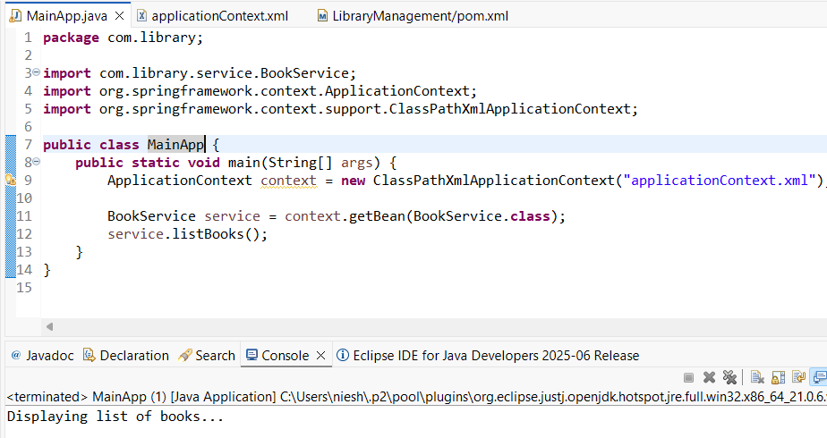
---------------------------------------------------------------------------------------------------------------------------
Exercise 7: Implementing Constructor and Setter Injection
Scenario:
The library management application requires both constructor and setter injection for better control over bean initialization.
1.MainApp.java
package com.library;
import com.library.service.BookService;
import org.springframework.context.ApplicationContext;
import org.springframework.context.support.ClassPathXmlApplicationContext;
public class MainApp {
public static void main(String[] args) {
ApplicationContext context = new ClassPathXmlApplicationContext("applicationContext.xml");
BookService service = context.getBean("bookService", BookService.class);
service.listBooks();
}
}
2.BookService.java
package com.library.service;
import com.library.repository.BookRepository;
public class BookService {
private BookRepository bookRepository;
private String serviceName;
// Constructor for constructor injection
public BookService(String serviceName) {
this.serviceName = serviceName;
System.out.println("Constructor Injection: serviceName = " + serviceName);
}
// Setter for setter injection
public void setBookRepository(BookRepository bookRepository) {
this.bookRepository = bookRepository;
System.out.println("Setter Injection: BookRepository set");
}
public void listBooks() {
System.out.println("Service: " + serviceName);
bookRepository.displayBooks();
}
}
3.BookRepository.java
package com.library.repository;
public class BookRepository {
public void displayBooks() {
System.out.println("Repository: Displaying list of books...");
}
}
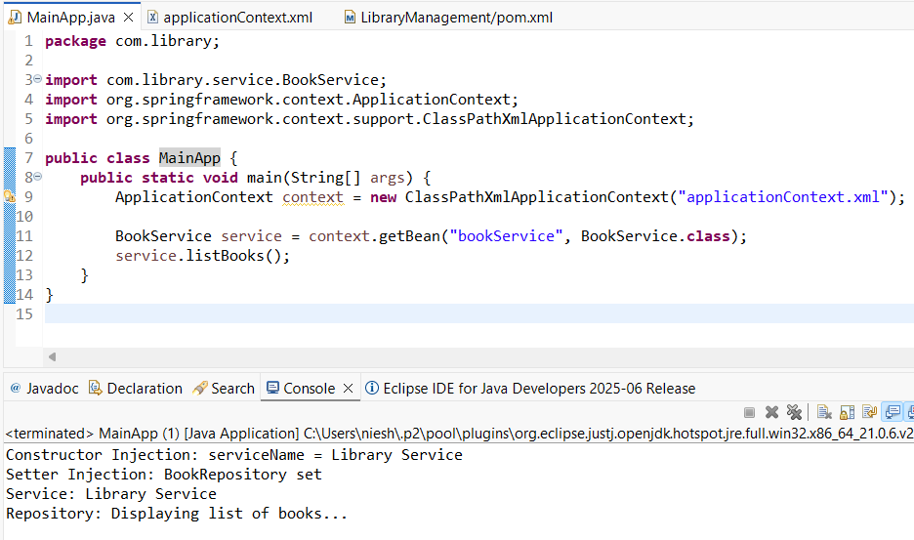
---------------------------------------------------------------------------------------------------------------------------
Exercise 8: Implementing Basic AOP with Spring
Scenario:
The library management application requires basic AOP functionality to separate cross-cutting concerns like logging and transaction management.
1,MainApp.java
package com.library;
import com.library.service.BookService;
import org.springframework.context.ApplicationContext;
import org.springframework.context.support.ClassPathXmlApplicationContext;
public class MainApp {
public static void main(String[] args) {
ApplicationContext context = new ClassPathXmlApplicationContext("applicationContext.xml");

BookService service = context.getBean("bookService", BookService.class);
service.listBooks();
}
}

2.LoggingAspect.java
package com.library.aspect;
import org.aspectj.lang.JoinPoint;
import org.aspectj.lang.annotation.After;
import org.aspectj.lang.annotation.Aspect;
import org.aspectj.lang.annotation.Before;
@Aspect
public class LoggingAspect {
@Before("execution(* com.library.service.*.*(..))")
public void logBefore(JoinPoint joinPoint) {
System.out.println("🔍 [Before] Executing method: " + joinPoint.getSignature().getName());
}
@After("execution(* com.library.service.*.*(..))")
public void logAfter(JoinPoint joinPoint) {
System.out.println("✅ [After] Completed method: " + joinPoint.getSignature().getName());
}
}
3.BookService.java
package com.library.service;
import com.library.repository.BookRepository;
public class BookService {
private BookRepository bookRepository;
private String serviceName;
// Setter for setter injection
public void setBookRepository(BookRepository bookRepository) {
this.bookRepository = bookRepository;
}
public void listBooks() {
System.out.println("Service: " + "EXERCISE-8");
bookRepository.displayBooks();
}
}
4.BookRepository.java
package com.library.repository;
public class BookRepository {
public void displayBooks() {
System.out.println("Repository: Displaying list of books...");
}
}
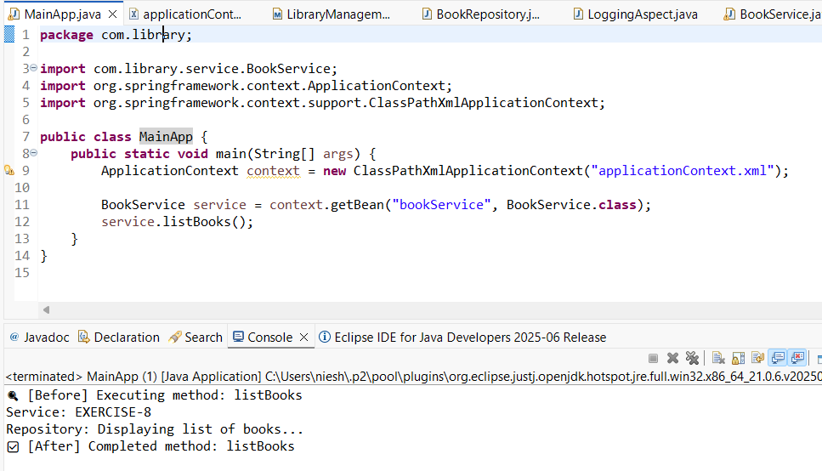
---------------------------------------------------------------------------------------------------------------------------
Exercise 9: Creating a Spring Boot Application
Scenario:
You need to create a Spring Boot application for the library management system to simplify configuration and deployment.
1.Book.java
package com.library.entity;
import jakarta.persistence.Entity;
import jakarta.persistence.GeneratedValue;
import jakarta.persistence.GenerationType;
import jakarta.persistence.Id;
@Entity
public class Book {
@Id
@GeneratedValue(strategy = GenerationType.IDENTITY)
private Long id;
private String title;
private String author;
public Book() {}
public Book(String title, String author) {
this.title = title;
this.author = author;
}
// Getters & setters
public Long getId() { return id; }
public String getTitle() { return title; }
public void setTitle(String title) { this.title = title; }
public String getAuthor() { return author; }
public void setAuthor(String author) { this.author = author; }
}
2.BookController.java
package com.library.controller;
import com.library.entity.Book;
import com.library.repository.BookRepository;
import org.springframework.beans.factory.annotation.Autowired;
import org.springframework.web.bind.annotation.*;
import java.util.List;
@RestController
@RequestMapping("/books")
public class BookController {
@Autowired
private BookRepository bookRepository;
@GetMapping
public List<Book> getAllBooks() {
return bookRepository.findAll();
}
@PostMapping
public Book createBook(@RequestBody Book book) {
return bookRepository.save(book);
}
@GetMapping("/{id}")
public Book getBook(@PathVariable Long id) {
return bookRepository.findById(id).orElse(null);
}
@PutMapping("/{id}")
public Book updateBook(@PathVariable Long id, @RequestBody Book bookDetails) {
Book existingBook = bookRepository.findById(id)
.orElseThrow(() -> new RuntimeException("Book not found with ID: " + id));
existingBook.setTitle(bookDetails.getTitle());
existingBook.setAuthor(bookDetails.getAuthor());
return bookRepository.save(existingBook);
}
@DeleteMapping("/{id}")
public void deleteBook(@PathVariable Long id) {
bookRepository.deleteById(id);
}
}
3.BookRepository.java
package com.library.repository;
import com.library.entity.Book;
import org.springframework.data.jpa.repository.JpaRepository;
public interface BookRepository extends JpaRepository<Book, Long> {
}
4.LibraryManagementBootApplication.java
package com.library;
import org.springframework.boot.SpringApplication;
import org.springframework.boot.autoconfigure.SpringBootApplication;
@SpringBootApplication
public class LibraryManagementBootApplication {
public static void main(String[] args) {
SpringApplication.run(LibraryManagementBootApplication.class, args);
}
}
#OUPUT CONSOLE
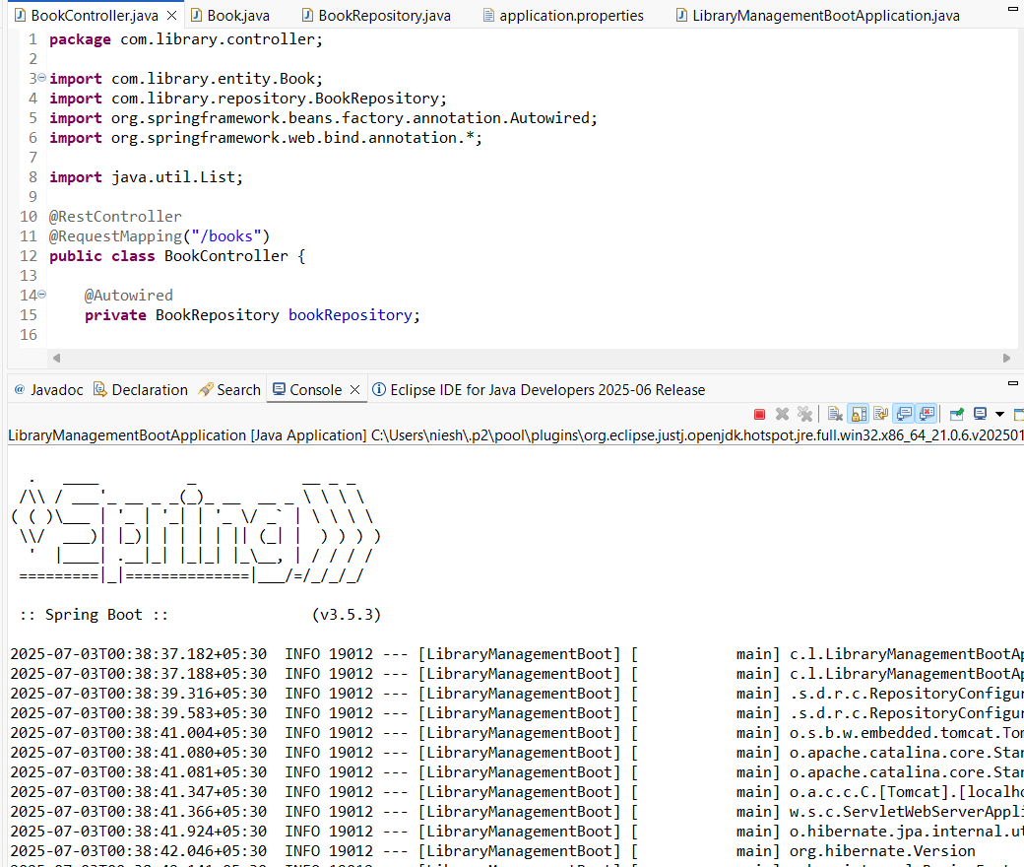

5.application.properties
spring.datasource.url=jdbc:h2:mem:librarydb
spring.datasource.driverClassName=org.h2.Driver
spring.datasource.username=sa
spring.datasource.password=
spring.jpa.database-platform=org.hibernate.dialect.H2Dialect
spring.jpa.hibernate.ddl-auto=update
spring.h2.console.enabled=true
server.port=808

#http://localhost:8081/books -> JSON
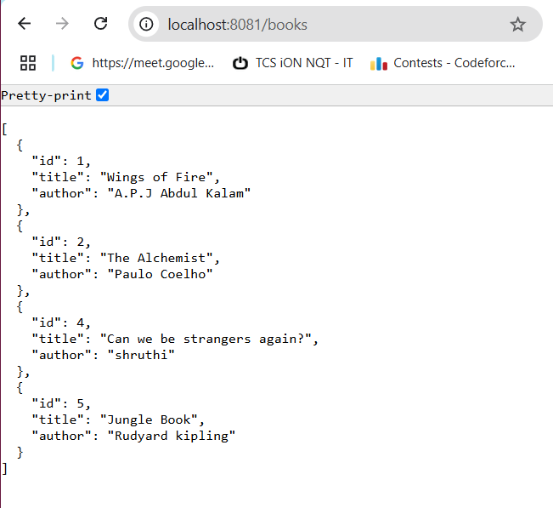

---------------------------------------------------------------------------------------------------------------------------

#http://localhost:8081/h2-console -> SQL DB
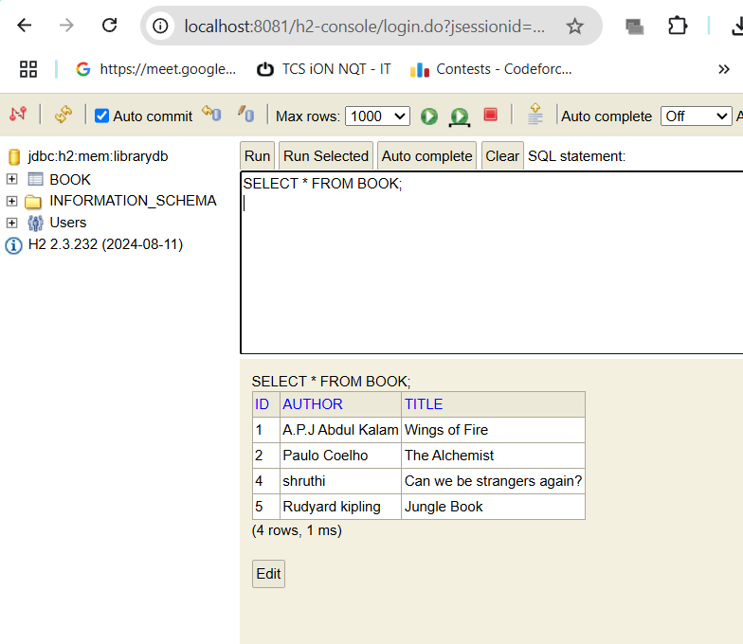

#using postman commands- POST,GET,PUT,DELETE



